LEWIS AND CLARK RECOVERY CAMPOUT
Sharing Our Experience, Strength and Hope “If your are not satisfied with your recovery, we will gladly refund your misery.”
September 21nd – 23th, 2018 Lewis and Clark State Park, Onawa, Ia
Make reservations for camping ahead of time, spaces fill-up fast: Reserving Camp Spots Online: http://travel.campsd.com/Campgrounds-and-RV Parks/All/Lewis-and-Clark-Recreation-Area/Reservations
Super 8 Hotel is also available if you would just like to participate in the activities, meetings and fellowship. Call: (712) 423-2101 for reservations.
Friday: 8:00pm Open Alcoholics Anonymous Campfire Meeting

Saturday: 7:00am Breakfast at the Lodge

8:00am Open Alcoholics Anonymous Meeting at the Lodge

10:00am Narcotics Anonymous Speaker Meeting: - Jody D. Dubuque, Ia
12:00pm Lunch at the Lodge

2:00pm Alanon Meeting

4:00pm Emotions Anonymous Speaker: - TBA

5:00pm Potluck at the Lodge

6:00pm Alanon Speaker: - TBA

7:00pm Alcoholics Anonymous A. Speaker: - Lee Annett N. Bettendorf, Ia
8:30pm Alcoholics Anonymous Campfire Meeting
Note: State Policy! Those persons not camping are required to leave the park before 10:00 pm. Thank you for your patience and cooperation!
Sunday: 10:00am Spiritual Speaker: - TBA

Come join us for Camping – Games - Fishing – Boating - Fellowship - Fun
Any Questions, call: 712-420-3013, or 712-420-2058
DIRECTIONS ON OTHER SIDE >>
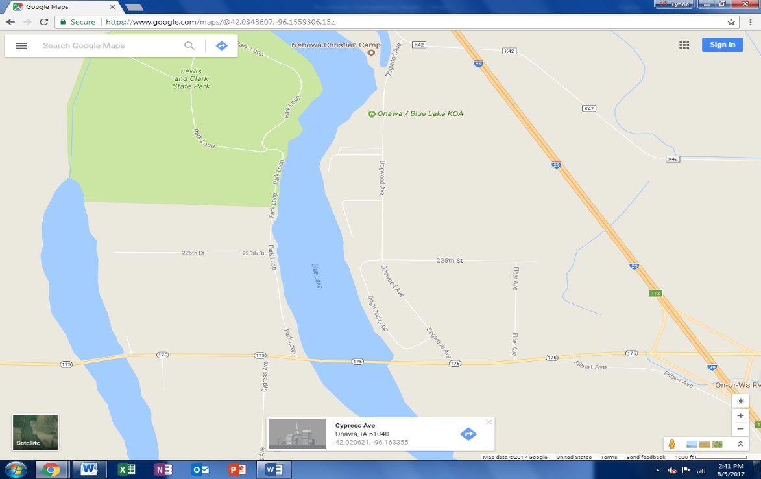

From Interstate 29 (I-29) take exit 112 to Hwy 175

On Hwy 175 head East Until you come Park Loop –
(Should you be coming West on 175, still turn North on Park Loop)
Head North on Park Loop (You are now at the Lewis and Clark State Park)
Continue heading North until you come to the Cabin Reception Center on the right.
You have arrived as pictured below:
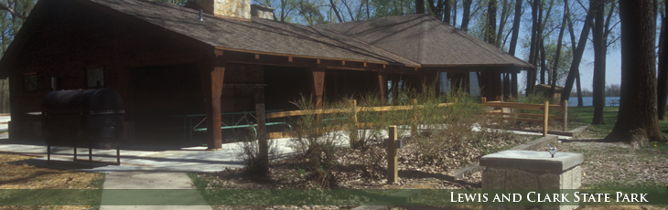
NOTE: Free will donations will be accepted for covering the expenses of this annual celebration. 7th Tradition says: “Every group ought to be fully self-supporting, declining outside contributions.” While contributions cover each group’s rent and other expenses, the Seventh Tradition is essential at every level of service.”

